**Healthy Food Co., Ltd. Deploys Two TCC 2 Ceiling Array Microphones to Enhance Sound Quality in Online Meetings**

**Smooth meetings also seen as beneficial from a management perspective**

**April 17, 2025**

Sennheiser Japan K.K.

屋内, 天井, シーン, テーブル が含まれている画像

AI によって生成されたコンテンツは間違っている可能性があります。

*Staff cafeteria/conference room at Healthy Food Co., Ltd. where the TCC 2 was installed*

Sennheiser’s industry-leading [**Team Connect Ceiling 2**](https://www.sennheiser.com/ja-jp/catalog/products/meeting-conference-systems/teamconnect-ceiling-2/teamconnect-ceiling-2-black-509161) (hereinafter, “TCC 2”) for large meeting rooms, lecture halls, or collaboration spaces, has been brought in as the meeting room microphones at the head office of Healthy Food Co., Ltd. (head office: Hino, Tokyo; Representative Director: Takashi Kuroda; hereinafter, “Healthy Food”), a food products company targeting medical and care facilities. Its representative director, Takashi Kuroda, says that “Operational noise during online meetings has been eliminated following introduction of the TCC 2, for which we are very grateful, and I feel that smooth meetings also offer benefits from a management perspective.”

Healthy Food handles food products that can be eaten by the elderly or disabled, developing and selling food products for medical and care facilities. Healthy Network Co., Ltd. was established in 1999 to expand its mail order business to patients at home, and is expanding its business overseas as well, especially in East Asia.

Mr. Kuroda looks back on his first encounter with the TCC 2 and the background to its introduction:

“Our person in charge during the construction of our new building found the TCC 2 online in February 2023. Our Systems Department strongly urged us to get one for the new building to solve our ongoing issues, so, after very careful consideration of the price and other factors, we opted to use it. Wanting to avoid having to lay out cables every time, we learned about ceiling microphones as a way to hold meetings smoothing, and ended up looking at the TCC 2.

建物の外観

AI によって生成されたコンテンツは間違っている可能性があります。

*The new Healthy Food Co., Ltd. building completed in February 2023*

“After that, we got a demonstration of the actual product, confirming its convenience and sound quality. As a ceiling-mounted microphone, there was no risk of things like cables getting cut, so it’s more convenient in terms of operation as well.”

Mr. Kuroda also noted that, regarding issues prior to bringing in the TCC 2, “When we have a study session or meeting with multiple bases checking in, it used to take us ages each time to set up equipment such as cameras and microphones.

“It was common to have voice-related issues such as being connected and yet unable to hear the other person, or them not being able to hear us well. If voices were faint, we would amplify them by putting the microphone in front of the speaker, for example, but these were not exactly smart ways of tackling the problem. Meetings are held to make decisions, so it’s important to be able to start off smoothly and minimize stress.”

屋内, テーブル, 椅子, 部屋 が含まれている画像

AI によって生成されたコンテンツは間違っている可能性があります。

*Smart meeting system that matches the new building design completed thanks to the TCC 2*

“However, one big issue is that the environment wasn’t adequate. In addition, there were concerns these sorts of large meetings could end up with only the side with more people getting engaged, leading to feelings of isolation and inadequate discussions. I’ve also taken in part in meetings from outside the company, so I’ve felt this personally.”

Mr. Kuroda says that the deciding factor in choosing the TCC 2 was its match with the specific needs of a food products company: “A key factor in our decision was its automatic dynamic beam forming performance, which can identify and follow a speaker.

“It offers both great sound quality and ease of use, and I feel we made the right decision to adopt it. Despite the microphones being on the ceiling, they still pick up sounds accurately, no matter where the speaker is. For example, during Q&A sessions during study meetings, we don’t where the person asking the question is sitting, but this microphone system can accurately pinpoint the speaker's location and send their voice to the online audience. Another point in its favor was that the TCC 2 is officially supported by the latest online meeting systems such as Zoom.

“In addition, we are a food products company, so we sometimes hold tasting sessions online. Noises like opening packaging paper can tend to overwhelm conversations during tasting sessions, but the TCC 2 has a had a big impact in being able to cancel out these noises accurately.”

人, 屋内, 男, テーブル が含まれている画像

AI によって生成されたコンテンツは間違っている可能性があります。

*Mr. Takashi Kuroda, Representative Director of Healthy Food Co., Ltd.*

Mr. Kuroda says that the employee cafeteria/conference room, where the TCC 2 has been installed, is mainly used for online meetings with between 15 and 25 people.

“This space is normally used as our staff cafeteria, but it also has two screens at the front and is used for online meetings with large numbers of people, or internal study sessions. With our study sessions, we sometimes invite lecturers from outside in addition to within the company.”

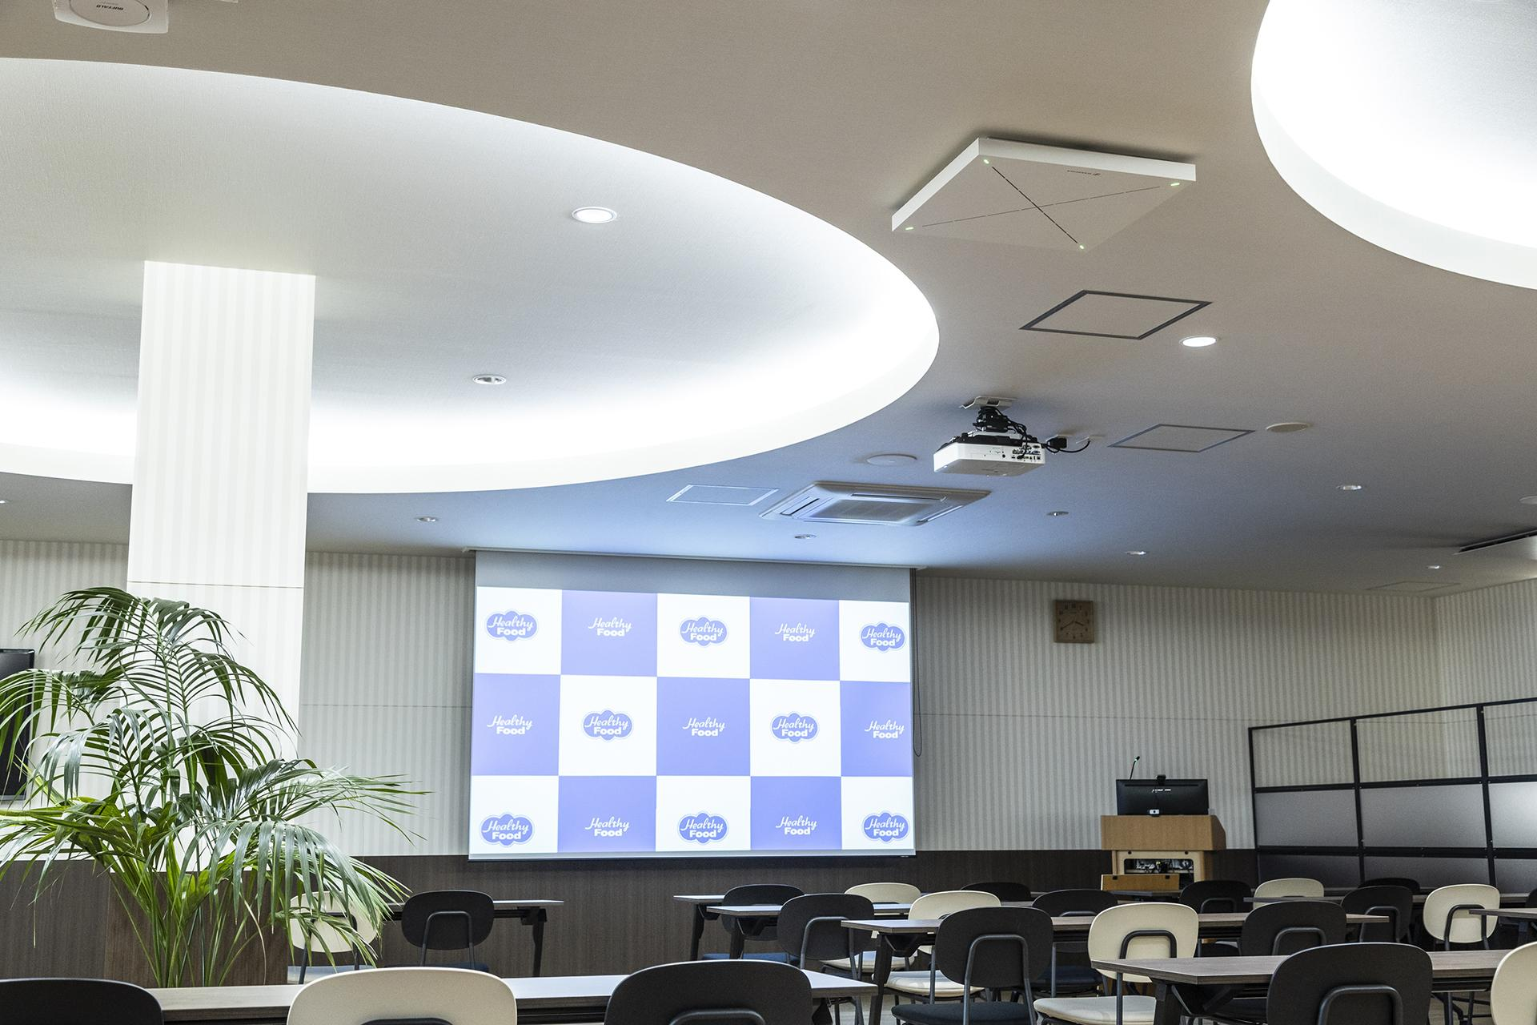

*Two TCC 2 microphones are installed in the ceiling to cover the entire room*

Moreover, Mr. Kuroda goes on to say that at Healthy Food, the TCC 2 microphones are being used in the same way for internal online meetings and study sessions with around 100 people held with a range of business locations.

“At Healthy Food, we have four business locations, as well as locally-stationed personnel, so most of online meetings are with these people. For example, we link with our business locations in Hokkaido, Osaka, Kyushu and so on to have sales report meetings every week. Through online meetings, our development and planning teams can also hear these reports.

“Moreover, we also hold study sessions using a combination of our new building and online. The other day, we had one with just under 100 people, connecting our sales offices in Kashiwa, Chiba Prefecture, and Ota, Gunma Prefecture. We hold these sorts of study sessions about twice a month.”

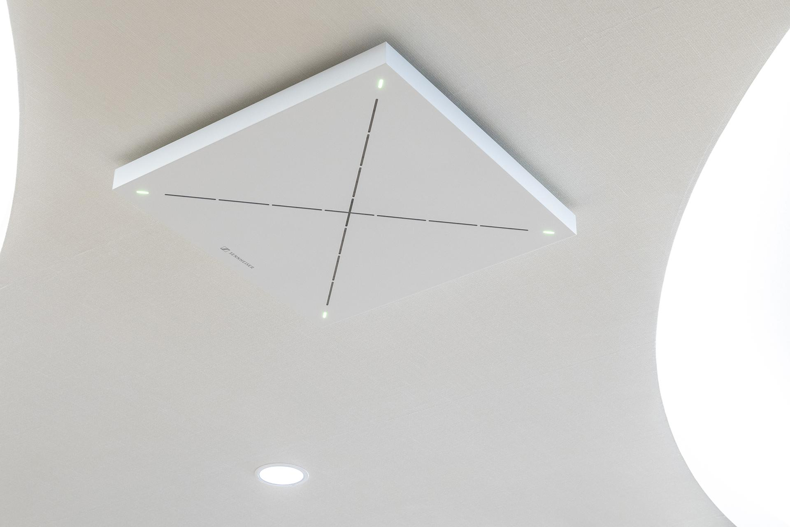

*The 28 internal microphones in a TCC 2 unit are controlled in a composite manner, providing a range of functions*

Mr. Kuroda evaluates the TCC 2 highly, saying of its TruVoicelift function that amplifies the speaker’s voice both automatically and appropriately, “Once you use this, you forget that the voice is being amplified.

“Previously, if we had a lot of people asking questions, we would have to pass the microphone around each time, which could cause problems, and in fact we got more noise from all this movement than from the speakers. In addition, compared to when people had to hold a microphone to talk, we can carry out discussions more smoothly without having to worry about extraneous stuff like equipment and voices, which means we can focus more on what we are talking about.”

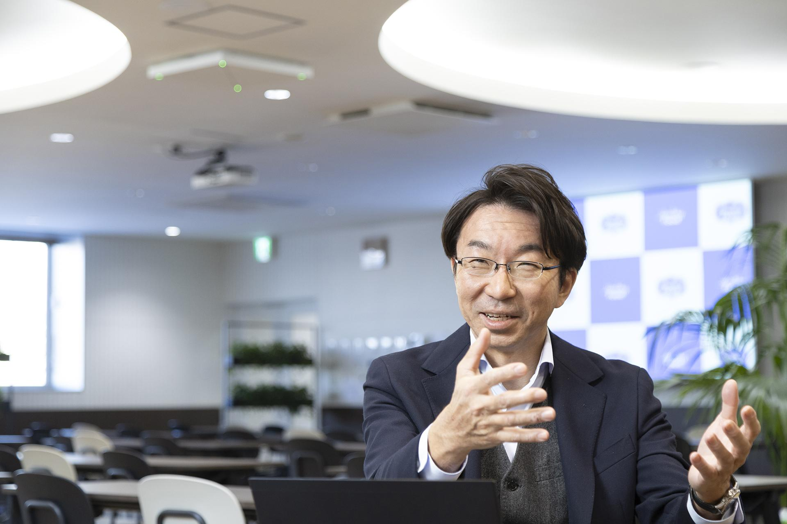

*Mr. Kuroda noting that smooth meetings are beneficial from a management perspective as well*

Mr. Kuroda, says that “Operational noise during online meetings or study sessions has been eliminated following introduction of the TCC 2 with its TruVoicelift function, for which we are very grateful, and I feel that smooth meetings also offer benefits from a management perspective.”

**About Healthy Food Co., Ltd.**

Founded in 1959, Healthy Food Co., Ltd. has focused on the sale of food products to medical and care facilities, starting with the manufacture and sale of fruit beverages. In addition to delivering both in-house products and manufacturer-branded products such as thick liquid foods, thickeners, and protein-adjusted foods to some 6,000 hospitals and nursing care facilities in the Kanto region and surrounding areas, as a manufacturer it also supplies its own products to hospitals and nursing care facilities nationwide through around 60 agencies. Starting in 1999, it has been providing these goods and services to customers around the country with the founding of Healthy Network Co., Ltd., its mail order business, in order to include patients undergoing dietary therapy at home.

<https://www.healthy-food-gr.jp/english.html>

**About the Sennheiser brand**

We live and breathe audio. We are driven by the passion to create audio solutions that make a difference. Building the future of audio and bringing remarkable sound experiences to our customers – this is what the Sennheiser brand has represented for more than 75 years. While professional audio solutions such as microphones, meeting solutions, streaming technologies and monitoring systems are part of the business of Sennheiser electronic SE & Co. KG, the business with consumer devices such as headphones, soundbars and speech-enhanced hearables is operated by Sonova Holding AG under the license of Sennheiser.

[www.sennheiser.com](http://www.sennheiser.com/)

[www.sennheiser-hearing.com](http://www.sennheiser-hearing.com/)